WORK

Work is defined as the product of the applied nett force and its displacement in the direction of the nett force.

i.e. W = Fs

where W = the work done (J-joules)
F = the nett force applied to the object (N)
s = the displacement of the object (m)

Work is a scalar quantity - no direction is required.

When work is done on an object, it changes the energy of the object.

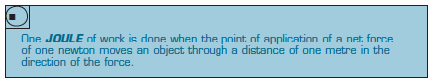

If the force is applied at an angle to the direction of movement, it is the component of the force responsible for the work done.
(This is Year 12 course work and will be covered then.)

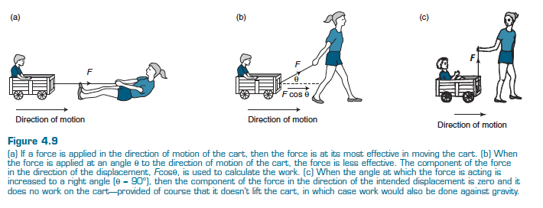
If a force is applied to an object and it does not move, then no work has been done.

e.g. 1. A person may push continuously against a parked car until exhausted, but if the
car does not move, no mechanical work has been done.

However, the person has expended a significant amount of work internally
(physiologically)!

2. Carrying a bag at a constant speed across the ground at a constant height has
no work done on it.

Reason: the energy of the bag has not changed.
(Se the section on Energy.)
Examples

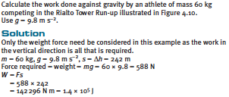
1.

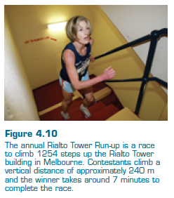

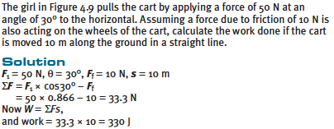
2.

Force - Displacement Graphs

The area under such a graph gives a measure of the work done by the force.

This is particularly useful in situations where a force changes with displacement, such as in collisions.

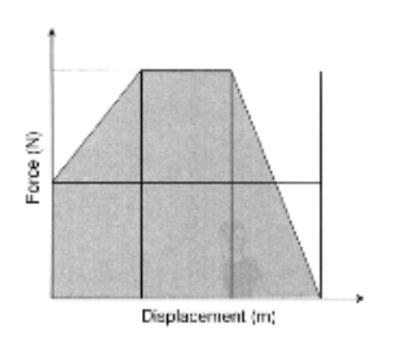

The area under the graph = W_{done}
= F_{ave} s

Thus it is possible to determine the average force which acted during the situation being studied.

